STAT 43000/MA 53001 Applied Statistics Spring 2023
Test 2-Part II (Answer key) Name:
Due: April 24, 2023.
Please provide the complete solutions of all problems.

Q.N. 1) (15 points) The dataset “lrb.dta” is provided with this assignment. All married Southern Baptists between the ages of 20 to 25 are in the data file. The variables included in this dataset are
happymar: respondent’s marital happiness
church: Church attendance
Gender (female):
educ: years of education, etc.

- Import the data in R to determine its dimension and print first five observations.
- Create a binary variable for happymar by using respondent’s marital happiness (1 = Very Happy, 0 = Otherwise).
- Run a simple logistic regression of happymar using years of educ and state the model equation.
- Test for significance of year of education to determine the marital happiness.
- Update the model in (c) using the variable female (1= female, 0 = male) to predict the probability of marital happiness of a female with 16 years of education

Solution: a) Based on the R output below there are 61 observations with 7 variables. First 5 observations are printed.
> library(foreign)
> data=read.dta("G:\\Aryal\\ STAT 43000\\Exams\\lrb.dta")
> head(data,5)
happymar church female educ cheduc educx cheducx
1 not as happy rarely in church male 9 0 -3.2786884 0.0000000
2 very happy rarely in church female 10 0 -2.2786884 0.0000000
3 very happy often in church female 16 16 3.7213116 3.7213116
4 very happy often in church female 11 11 -1.2786884 -1.2786884
5 very happy often in church female 12 12 -0.2786884 -0.2786884

> dim(data)
[1] 61 7

b) We used R code below to create the binary variable y

> y=(happymar=="very happy")*1
> y
[1] 0 1 1 1 1 0 1 1 0 1 1 1 1 1 0 0 1 1 0 0 0 1 0 1 1 1 1 1 1 1 1 0 1 0 0 1 1 0 1 1 0 0 1 0 1 1 0 1 0 1 1 0 1 1 1 0 0 1 1 0 1

c) We used R code below to develop the logistic regression model.Based on the R output the fitted logistic regression model is

where x= years of education.
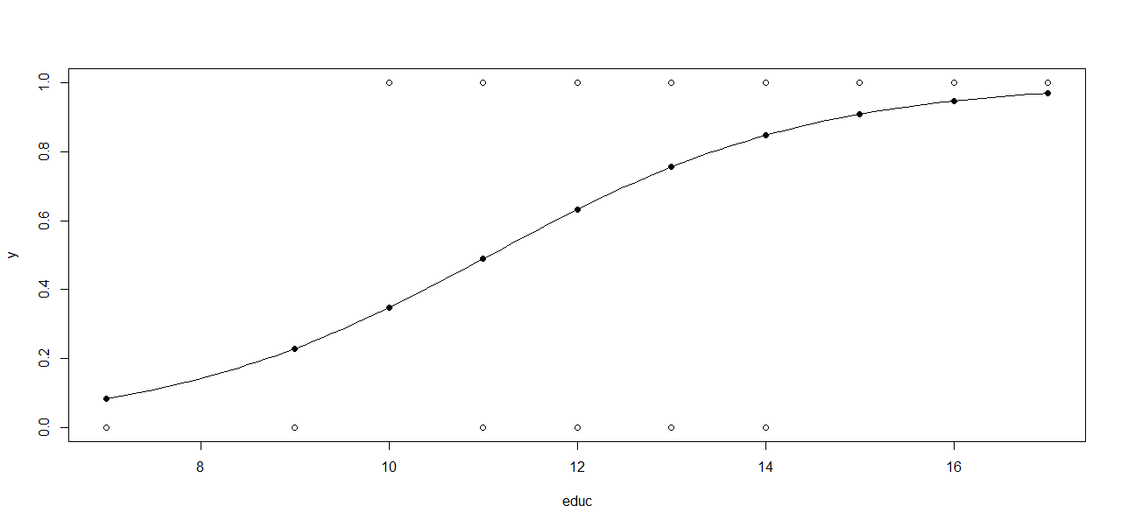
> model=glm(y~educ, family="binomial")
> summary(model)

Call:
glm(formula = y ~ educ, family = "binomial")

Deviance Residuals:
Min 1Q Median 3Q Max
-1.9371 -1.1585 0.5766 0.9582 1.4537

Coefficients:
Estimate Std. Error z value Pr(>|z|)
(Intercept) -6.4782 2.6750 -2.422 0.01545 *
educ 0.5849 0.2235 2.617 0.00887 **
---
Signif. codes: 0 ‘***’ 0.001 ‘**’ 0.01 ‘*’ 0.05 ‘.’ 0.1 ‘ ’ 1

(Dispersion parameter for binomial family taken to be 1)

Null deviance: 79.763 on 60 degrees of freedom
Residual deviance: 69.602 on 59 degrees of freedom
AIC: 73.602

Number of Fisher Scoring iterations: 4

>curve(predict(model, data.frame(educ= x),type= "resp"),add=T)
>points(educ, fitted(model), pch=19)

d) Based on the R output in part (c) the p-value corresponding to education is 0.00887 which is less than 0.05 so we can conclude that the years of education is a significant variable to determine the marital happiness.

e) We used R code below to update the model and the predicted probability that a female with 16 years of education will be very happy with her marriage is 0.974

> gender=(female=="female")*1
> newmodel=glm(y~educ+gender, family="binomial")
> newmodel
Call: glm(formula = y ~ educ + gender, family = "binomial")
Coefficients:
(Intercept) educ gender
-7.4102 0.6016 1.4214

Degrees of Freedom: 60 Total (i.e. Null); 58 Residual
Null Deviance: 79.76
Residual Deviance: 63.93 AIC: 69.93

> predict(newmodel, data.frame(educ=16, gender=1), type="resp")
1
0.9743252

Q.N. 2) (5 Points) Given four treatments, a sample size of five observations of the response variable per treatment, TSS = 400 and SSE = 100, determine the analysis of variance table and test the null
hypothesis of no treatment differences, on average, support your conclusion.

Solution: We have
a = 4, df = a – 1 = 4 – 1 = 3
N = 4 * 5 = 20
TSS = 400
SSE = 100
Error df = N – a = 20 – 4 = 16
Total df = N – 1 = 20 – 1 = 19

Source of Variation | DF | Sum of Squares | MS | F-value | p-value
Model | 3 | 300 | 100 | 16 | 0.000045
Error | 16 | 100 | 6.25
Total | 19 | 400

Since the computed p-value is less than 0.05, we reject the null hypothesis of no treatment effect and conclude that there is at least one pair of treatment means that are different.

Q. N. 3)(10 Points) A chemist wishes to test the effect of four chemical agents on the strength of a particular type of cloth. Because there might be variability from one bolt to another, the chemist decides to use a randomized block design, with the bolts of cloths considered as blocks. She selects five bolts and applies all four chemicals in random order to each bolt. The resulting tensile strengths are as follows.
 | Bolt
Chemical | 1 | 2 | 3 | 4 | 5
I | 73 | 68 | 74 | 71 | 67
II | 73 | 67 | 75 | 72 | 70
III | 75 | 68 | 78 | 73 | 68
IV | 73 | 71 | 75 | 75 | 69

- Analyze the data from the experiment at α = 0.05 and draw appropriate conclusions.
- Test for model assumption to justify your model

Solution:
- Let 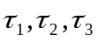 and 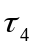denotes the effects of the chemical 1, chemical 2, chemical 3 and chemical 4 respectively. Then we want to test the following hypothesis
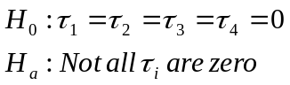

We can use R code below to perform the test.

> Bolt=c("B1","B1","B1","B1","B2","B2","B2","B2","B3","B3","B3","B3","B4","B4","B4","B4","B5","B5","B5","B5")
> Chemical=c(1,2,3,4,1,2,3,4,1,2,3,4,1,2,3,4,1,2,3,4)
> strength=c(73,73,75,73,68,67,68,71,74,75,78,75,71,72,73,75,67,70,68,69)
> newdata=data.frame(Bolt,Chemical,strength)
> model=aov(strength~Bolt+factor(Chemical))
> summary(model)
Df Sum Sq Mean Sq F value Pr(>F)
Bolt 4 157.00 39.25 21.606 2.06e-05 ***
factor(Chemical) 3 12.95 4.32 2.376 0.121
Residuals 12 21.80 1.82
---
Signif. codes: 0 ‘***’ 0.001 ‘**’ 0.01 ‘*’ 0.05 ‘.’ 0.1 ‘ ’ 1
Since the P-value (0.121) is greater than 0.05 the chemical effect is not significant at =0.05.This means there is no difference in strength based on chemical type at α = 0.05.

- In order to test the model assumptions, we have plotted the normal probability plot and the plot of the residuals versus the predicted values and we have the graphs as below and there is no indication of severe problem.

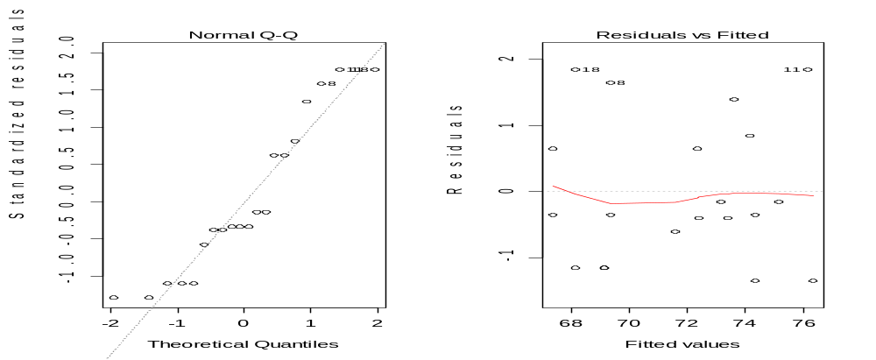

Q.N. 4) (10 Points) The effective life of insulating fluids at an accelerated load of 35 KV is being studied. Test data have been obtained for four types of fluids. The result from a completely randomized experiment is as follows:
Type I | Type II | Type III | Type IV
17.6 | 16.9 | 21.4 | 19.3
18.9 | 15.3 | 23.6 | 21.1
16.3 | 18.6 | 19.4 | 16.9
17.4 | 17.1 | 18.5 | 17.5
20.1 | 19.5 | 20.5 | 18.3
21.6 | 20.3 | 22.3 | 19.8

- Is there any indication that the fluids differ at α = 0.1? What about at α = 0.05?
- Use the Tukey’s HSD test to identify the fluid types that are different (if any).
- Which fluid would you select, given that the objective is long life?
- Analyze the residuals from this experiment. Are the basic analysis of variance assumptions satisfied?
- Use the Kruskal-Wallis test and compare the results with the one you got from above steps.

a) Let 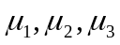 and 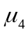 denote the mean of fluid type 1 type 2, type 3 and type 4 respectively. We want to test the following hypothesis

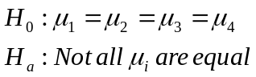

We use R code below to import the data and create ANOVA table

> T1=scan()
1: 17.6
2: 18.9
3: 16.3
4: 17.4
5: 20.1
6: 21.6
7:
Read 6 items
> T2=scan()
1: 16.9
2: 15.3
3: 18.6
4: 17.1
5: 19.5
6: 20.3
7:
Read 6 items
> T3=scan()
1: 21.4
2: 23.6
3: 19.4
4: 18.5
5: 20.5
6: 22.3
7:
Read 6 items
> T4=scan()
1: 19.3
2: 21.1
3: 16.9
4: 17.5
5: 18.3
6: 19.8
7:
Read 6 items
> data=data.frame(T1,T2,T3,T4)

> data
T1 T2 T3 T4
1 17.6 16.9 21.4 19.3
2 18.9 15.3 23.6 21.1
3 16.3 18.6 19.4 16.9
4 17.4 17.1 18.5 17.5
5 20.1 19.5 20.5 18.3
6 21.6 20.3 22.3 19.8
> y=c(T1,T2,T3,T4)
> y
[1] 17.6 18.9 16.3 17.4 20.1 21.6 16.9 15.3 18.6 17.1 19.5 20.3 21.4 23.6 19.4
[16] 18.5 20.5 22.3 19.3 21.1 16.9 17.5 18.3 19.8
> type=rep(c("Type1","Type2","Type3","Type4"),c(6,6,6,6))
> type
[1] "Type1" "Type1" "Type1" "Type1" "Type1" "Type1" "Type2" "Type2" "Type2"
[10] "Type2" "Type2" "Type2" "Type3" "Type3" "Type3" "Type3" "Type3" "Type3"
[19] "Type4" "Type4" "Type4" "Type4" "Type4" "Type4"

> summary(aov(y~type))
Df Sum Sq Mean Sq F value Pr(>F)
type 3 30.16 10.05 3.047 0.0525 .
Residuals 20 65.99 3.30
---
Signif. codes: 0 ‘***’ 0.001 ‘**’ 0.01 ‘*’ 0.05 ‘.’ 0.1 ‘ ’ 1
>
The F-value is 3.047 with the corresponding p-value 0.0525 which is slightly bigger than our α =0.05). This implies we fail to reject the null hypothesis at α = 0.05. But the p-value 0.0525 is smaller than 0.1. This means we reject the null hypothesis at α = 0.1.

b)
> TukeyHSD(aov(y~type))

> TukeyHSD(aov(y~type))
Tukey multiple comparisons of means
95% family-wise confidence level

Fit: aov(formula = y ~ type)

$type
diff lwr upr p adj
Type2-Type1 -0.7000000 -3.63540073 2.2354007 0.9080815
Type3-Type1 2.3000000 -0.63540073 5.2354007 0.1593262
Type4-Type1 0.1666667 -2.76873407 3.1020674 0.9985213
Type3-Type2 3.0000000 0.06459927 5.9354007 0.0440578
Type4-Type2 0.8666667 -2.06873407 3.8020674 0.8413288
Type4-Type3 -2.1333333 -5.06873407 0.8020674 0.2090635

It appears that Type II and Type III are significantly different.

c) 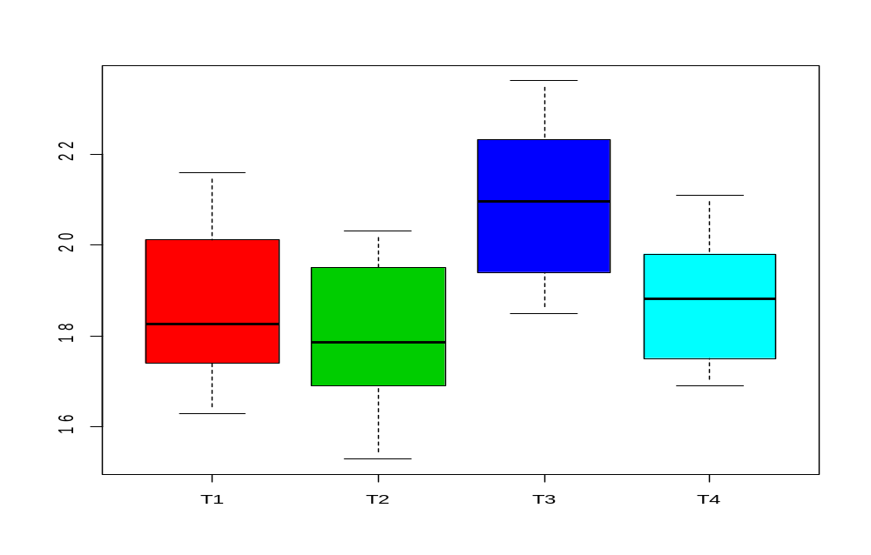
Fluid Type III should be chosen for higher is better.

- Based on the residual plots, yes the model assumption seems to satisfy
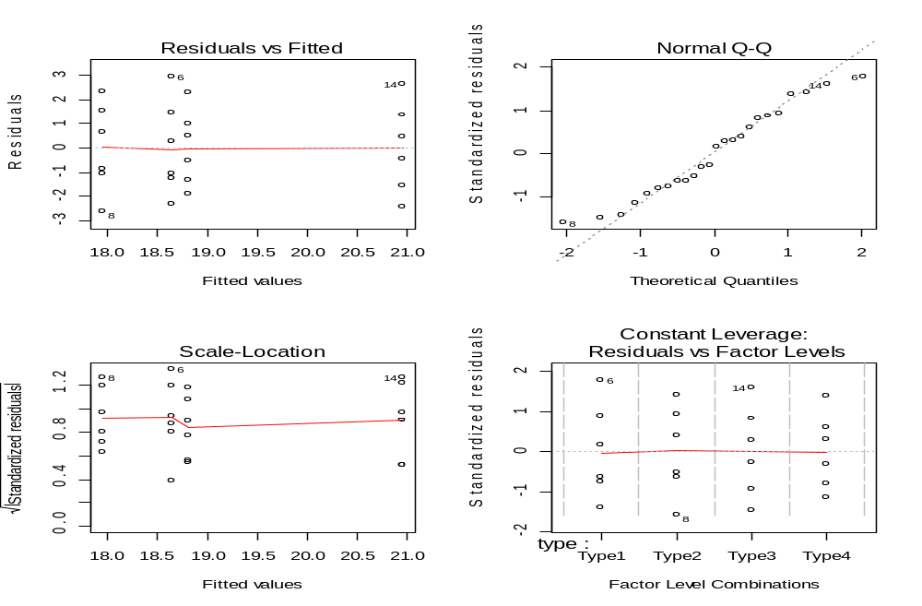

- Let and denote the mean of fluid type 1 type 2, type 3 and type 4 respectively. We want to test the following hypothesis

We can use R code below to perform the nonparametric Kruskal-Wallis test

> kruskal.test(y~type)

Kruskal-Wallis rank sum test

data: y by type
Kruskal-Wallis chi-squared = 6.2177, df = 3, p-value = 0.1015

Since p-value> 0.05 we fail to reject the null hypothesis.
Yes, it does agree with the analysis of variance at 0.05 level of significance but not at
0.1 level of significance.

Q.N. 5)(10 Points) An aluminum master alloy manufacturer produces grain refiners in ingot form. The company produces the product in four furnaces (A,B,C,D). Each furnace is known to have its own unique operating characteristics, so any experiment run in the foundry that involves more than one furnace will consider furnaces as a nuisance variable. The process engineers suspect that stirring rate affects the grain size of the product. Each furnace can be run at four different stirring rates. A randomized block design is run for a particular refiner, and the resulting grain size data are as follows.

 | Furnace
Stirring Rate (rpm) | A | B | C | D
5 | 8 | 4 | 5 | 6
10 | 14 | 5 | 6 | 9
15 | 14 | 6 | 9 | 2
20 | 17 | 9 | 3 | 6

- Is there any evidence that stirring rate affects grain size. Perform the RCBD using Furnace as a blocking factor to investigate it.
- Suppose that the observation for Furnace C at the Stirring rate 10 rpm is missing ( The highlighted value (6). If you would like to estimate this value by minimizing SSE, please estimate its value.

> Furnace=c("A","A","A","A","B","B","B","B","C","C","C","C","D","D","D","D")
> stirring=c(5,10,15,20,5,10,15,20,5,10,15,20,5,10,15,20)
> grain=c(8,14,14,17,4,5,6,9,5,6,9,3,6,9,2,6)
> fit=aov(grain~Furnace+factor(stirring))
> summary(fit)
Df Sum Sq Mean Sq F value Pr(>F)
Furnace 3 165.19 55.06 6.348 0.0133 *
factor(stirring) 3 22.19 7.40 0.853 0.4995
Residuals 9 78.06 8.67
---
Signif. codes: 0 ‘***’ 0.001 ‘**’ 0.01 ‘*’ 0.05 ‘.’ 0.1 ‘ ’ 1

From the R output on conducting RCBD using Furnace as a blocking factor, the p-value associated to the test of no difference on stirring rate is 0.4495. Since p-value > 0.05 we fail to reject the null hypothesis and conclude that there is no evidence that stirring rate affect grain size.

 | Furnace
Stirring Rate (rpm) | A | B | C | D
5 | 8 | 4 | 5 | 6 | 23
10 | 14 | 5 | x | 9 | 28+x
15 | 14 | 6 | 9 | 2 | 31
20 | 17 | 9 | 3 | 6 | 35
Total | 53 | 24 | 17+x | 23 | 117+x

Observe that the SSE can be written as
Now differentiating SSE with respect to equating to 0 and solving we get 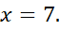

Therefore, the missing value has been estimated to be 7.

